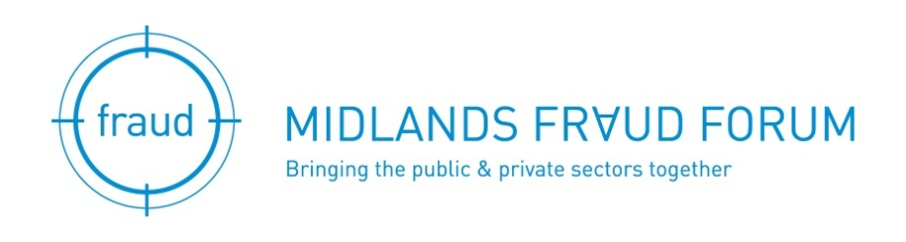
MIDLANDS FRAUD FORUM MASTERCLASS
9 JUNE 2016

‘Fraud Investigations’
Thursday 9 June 2016 – 8.30am to 11.45am
Hosted by Capital One (Europe) plc.
Trent House, Station Street, Nottingham, NG2 3HX

AGENDA

08.30 | Registration and Refreshments
09.00 | Welcome & introduction
09.05 | Nir Tolkovsky – The Duality of Fraud in English Law and Practice
09.45 | DS Sue Howell, Nottinghamshire Police Economic Crime Unit – ‘Fraud Investigation – New Horizons
10.25 | Coffee
10:45 | Capital One (Europe) plc – Adrian Beech on Fraud prevention/detection from a credit card provider
11.30 | Questions to the speakers
11.45 | Close

Speakers

Nir Tolkovsky MSc CFE

Nir is a final year PhD candidate at the University of Derby and a guest lecturer on its Criminology graduate and Criminal Investigation post-graduate courses.

Nir has a highly diverse practical background, which includes service as an Israeli intelligence officer and applied research and development on the use of forensic technologies and analytics in law enforcement and fraud related litigation in the UK.

His doctoral research examines the interplay and duality between criminal and civil applications of fraud in English law.

Nottinghamshire Police Economic Crime Unit

DS Sue Howell - DS Sue Howell is one of the Forces most experienced fraud investigators. She has built up a wealth of knowledge during her fifteen years in the role and during that period has seen countless offenders convicted through her work.

Of her recent successes Sue was instrumental in securing the conviction of two directors of a Nottingham based investment company who were responsible for obtaining over £50 million through a series of fraudulent misrepresentations. A competent SIO in her own right Sue has recently acted as Head of the Department and remains as keen as ever in taking on new investigations.

As the Force gets to grips with determining a coherent, coordinated and stronger response to fraud investigation Sue has taken on further responsibilities in respect of volume fraud enquiries (Action Fraud) and equally as important, the new national Protect strategy which is currently being rolled out in support of victims and potential victims of fraud.

Capital One (Europe) UK

Adrian Beech - Senior Fraud Operations and Supplier Manager.

Adrian has been involved in criminal investigations for over 10 years, working with the Home Office and Nottinghamshire Police as a Detective Sgt prior to joining Capital One three years ago as Head of Fraud Investigations and Fraud Systems.

Capital One leads the industry in Fraud prevention and has the lowest Fraud losses in the industry (recently recognised by Mastercard for this achievement). They have also achieved Fraud team of the year for 3 of the last 4 years at the Card and Payments awards.

The team prides itself on its dedication to disrupt fraudsters, achieving a record 43 arrests from pro-active police referrals in 2015, with numerous custodial sentences.
Adrian has recently changed roles becoming a senior manager within fraud operations managing UK and overseas suppliers.

REGISTRATION/APPLICATION FORM

The Master Class is free for Midlands Fraud Forum members or a substitute colleague from their organisation.

Non-members can attend at a cost of £60.00 which includes attendance at any other master class during the next year (excluding the annual conference)

Registration for this event can now be made by members on the website by clicking here or paste this address to your browser:

http://www.midlandsfraudforum.co.uk/event-2241288

Manual applicants should complete the details below:

Master Class : ___________________________________________________________

Master Class date: ________________________________________________________

For non-members or replacement colleagues please complete the details below and return it to Sylvia Jones at info@midlandsfraudforum.co.uk or telephone 0121 356 1754

I am unable to attend but would like a replacement from my company to attend, please see details below.

Yes, I’d like to attend the Masterclass but I am not a member of Midlands Fraud Forum.

I enclose a cheque for £60 payable to Midlands Fraud Forum.

Please send me an invoice to the address below.

Please complete the details below using capitals throughout.

Members name _______________________________________________________________

Attendee name _______________________________________________________________

Job Title ____________________________ Company _________________________________

Address _____________________________________________________________________

_______________________________Postcode________________________________

Telephone Number ______________________Email __________________________________

Why not visit: www.midlandsfraudforum.co.uk

Follow us on twitter @MFF_Forum

